Task 1: Execute all yaml files shown in video.
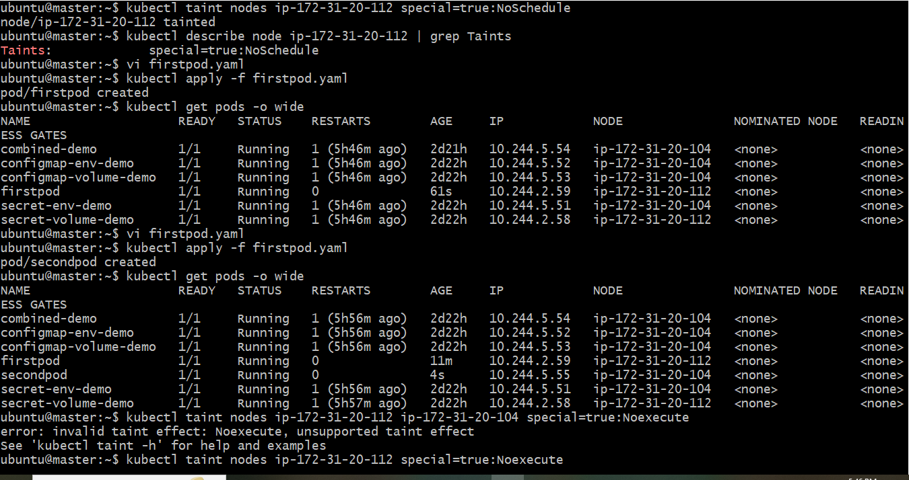
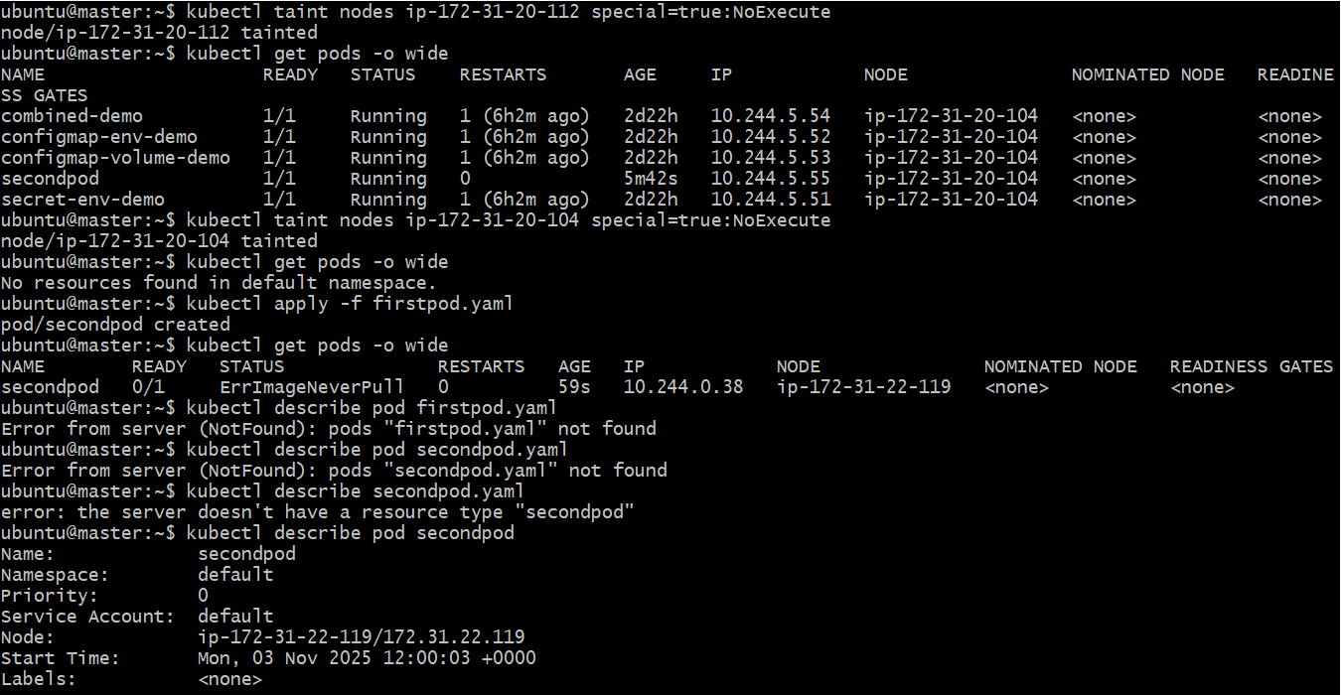
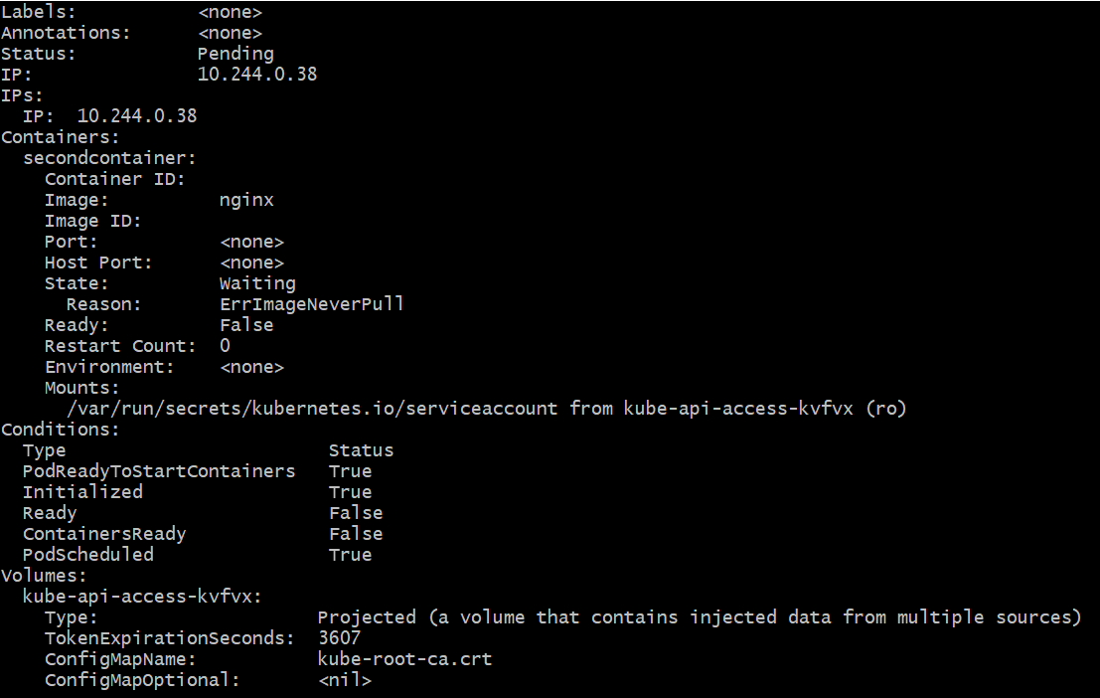
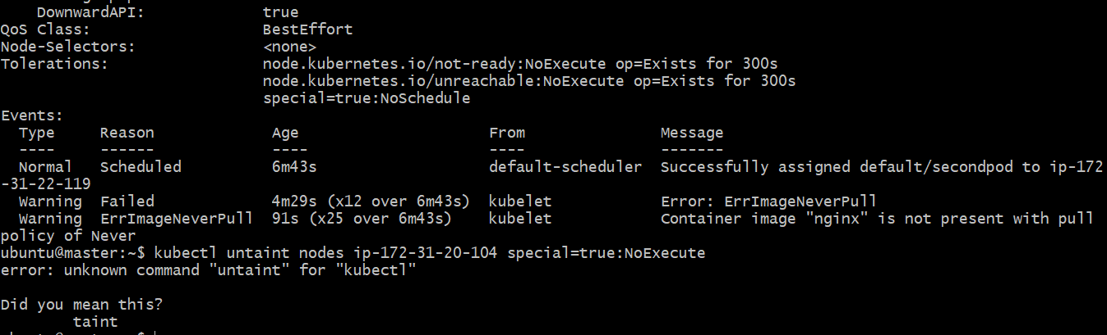
Task 2: Taint a Node and Schedule a Tolerant Pod Taint a node with special=true:NoSchedule. Create a pod with a toleration that matches the taint, allowing it to be scheduled on the tainted node.

🪣 Step 1: Taint the Node
Pick one of your worker nodes, for example worker1.
Run:
kubectl taint nodes worker1 special=true:NoSchedule
✅ This adds a taint with:
- Key = special
- Value = true
- Effect = NoSchedule (blocks non-tolerant pods)

🔍 Verify the Taint
kubectl describe node worker1 | grep Taints
You should see:
Taints: special=true:NoSchedule

🧩 Step 2: Create a Pod with a Matching Toleration
Create a YAML file named tolerant-pod.yaml:
apiVersion: v1
kind: Pod
metadata:
name: tolerant-pod
spec:
tolerations:
- key: "special"
operator: "Equal"
value: "true"
effect: "NoSchedule"
containers:
- name: nginx
image: nginx

🚀 Step 3: Apply the Pod
kubectl apply -f tolerant-pod.yaml

✅ Step 4: Verify Pod Scheduling
Check where the pod is running:
kubectl get pods -o wide
You should see tolerant-pod scheduled on worker1 (the tainted node).

🧹 Step 5: (Optional) Remove the Taint Later
If you want to remove the taint:
kubectl taint nodes worker1 special=true:NoSchedule-

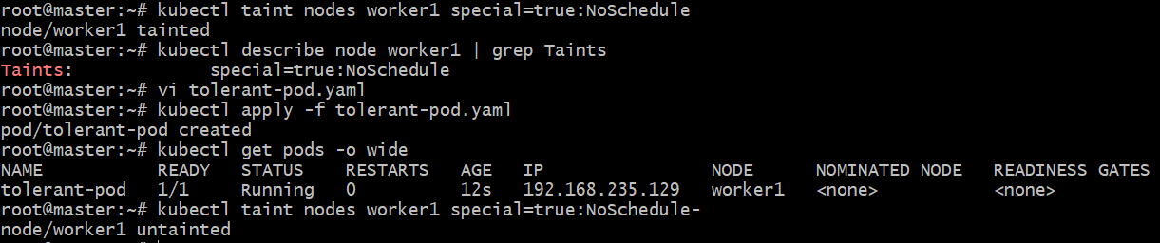
Task 3: Use NodeSelector to Schedule a Pod on a Specific Node Label a node with env=dev. Create a pod with a nodeSelector that schedules it only on the node labeled env=dev.

Step 1: Label the Node
Let’s label worker2 as a development node:
kubectl label node worker2 env=dev
✅ You can verify:
kubectl get nodes --show-labels
You should see something like:
NAME STATUS ROLES AGE VERSION LABELS
master Ready control-plane 15m v1.29.15 ...
worker1 Ready worker 10m v1.29.15 ...
worker2 Ready worker 9m v1.29.15 env=dev

🧩 Step 2: Create a Pod with nodeSelector
Create a YAML file named dev-pod.yaml:
apiVersion: v1
kind: Pod
metadata:
name: dev-pod
spec:
nodeSelector:
env: dev
containers:
- name: nginx
image: nginx

🚀 Step 3: Deploy the Pod
kubectl apply -f dev-pod.yaml

✅ Step 4: Verify Scheduling
Check where it landed:
kubectl get pods -o wide
You should see:
NAME READY STATUS NODE
dev-pod 1/1 Running worker2
That confirms it was scheduled on the env=dev node.

🧹 Optional: Remove the Label Later
If you want to remove the label from the node:
kubectl label node worker2 env-

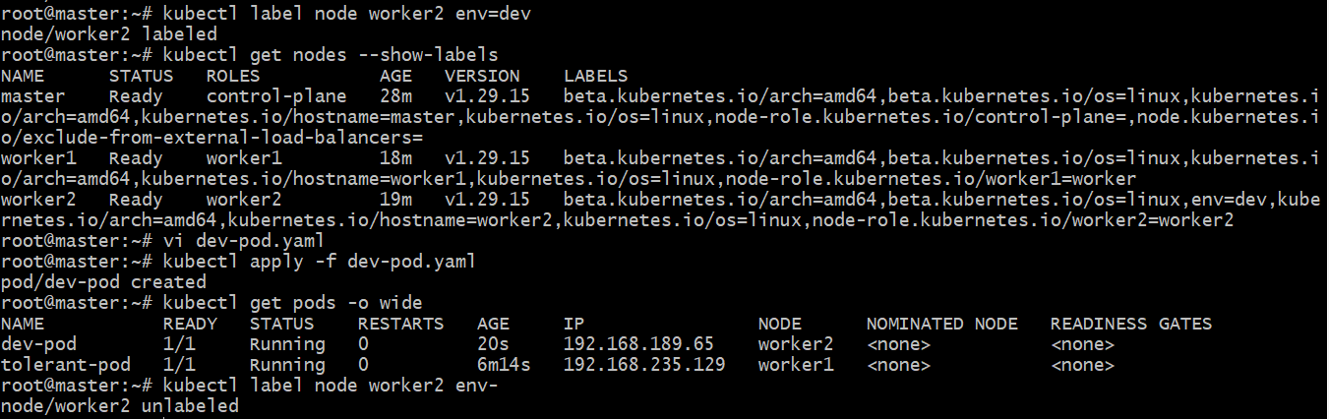
Task 4: Use Node Affinity with Soft Scheduling Label a node with env=test. Create a pod with PreferredDuringSchedulingIgnoredDuringExecution node affinity, preferring to schedule it on a node labeled env=test. Remove the label and verify the pod continues to run.

🪣 Step 1: Label a Node
Let’s label worker1 as a test node:
kubectl label node worker1 env=test
✅ Verify:
kubectl get nodes --show-labels
You should see something like:
NAME STATUS ROLES AGE VERSION LABELS
worker1 Ready worker 10m v1.29.15 env=test

🧩 Step 2: Create a Pod with Preferred Node Affinity
Create a YAML file named affinity-pod.yaml:
apiVersion: v1
kind: Pod
metadata:
name: affinity-pod
spec:
affinity:
nodeAffinity:
preferredDuringSchedulingIgnoredDuringExecution:
- weight: 1
preference:
matchExpressions:
- key: env
operator: In
values:
- test
containers:
- name: nginx
image: nginx

Explanation:
- preferredDuringSchedulingIgnoredDuringExecution = soft rule (preference, not strict requirement)
- If no node matches, it will still schedule elsewhere.
- The “IgnoredDuringExecution” part means that even if the label is removed later, the Pod keeps running.

🚀 Step 3: Apply the Pod
kubectl apply -f affinity-pod.yaml

✅ Step 4: Verify Pod Scheduling
kubectl get pods -o wide
You should see:
NAME READY STATUS NODE
affinity-pod 1/1 Running worker1

🧹 Step 5: Remove the Label
Now remove the label from the node:
kubectl label node worker1 env-

🔍 Step 6: Verify the Pod Still Runs
Check again:
kubectl get pods -o wide
✅ You’ll notice affinity-pod still running on worker1.
That’s because the “IgnoredDuringExecution” rule allows it to continue — it only applies during scheduling, not after the Pod is running.

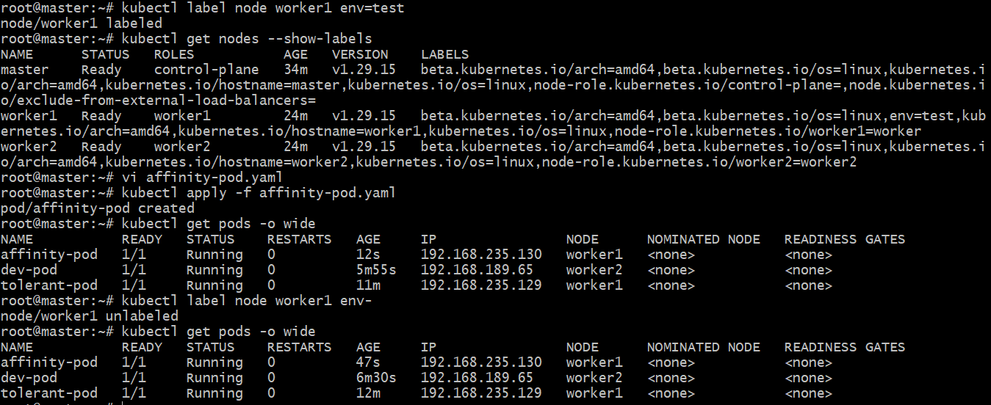
Task 5: Implement Node Affinity with Hard Scheduling Create a pod with RequiredDuringSchedulingIgnoredDuringExecution node affinity, ensuring it will only be scheduled on a node labeled env=prod. Verify the pod cannot be scheduled if no node has the env=prod label.

🧩 Step 1: Create a Pod Manifest with Hard Node Affinity
Create a YAML file named hard-affinity-pod.yaml:
apiVersion: v1
kind: Pod
metadata:
name: hard-affinity-pod
spec:
affinity:
nodeAffinity:
requiredDuringSchedulingIgnoredDuringExecution:
nodeSelectorTerms:
- matchExpressions:
- key: env
operator: In
values:
- prod
containers:
- name: nginx
image: nginx

🧠 Explanation:
- requiredDuringSchedulingIgnoredDuringExecution = hard requirement
- The Pod will only schedule on nodes with label env=prod.
- “IgnoredDuringExecution” means once scheduled, removing the label later won’t evict it.

🚀 Step 2: Apply the Pod (Before Labeling Any Node)
kubectl apply -f hard-affinity-pod.yaml

🔍 Step 3: Check Pod Status
kubectl get pods
You should see something like:
NAME READY STATUS REASON NODE
hard-affinity-pod 0/1 Pending Unschedulable <none>
To see why:
kubectl describe pod hard-affinity-pod | grep -A4 "Events"
You’ll see a message like:
0/3 nodes are available: 3 node(s) didn't match node affinity/selector.

🪣 Step 4: Label a Node with env=prod
Let’s label one of your worker nodes (say worker2):
kubectl label node worker2 env=prod

✅ Step 5: Verify Pod is Now Scheduled
Check again:
kubectl get pods -o wide
Now you’ll see:
NAME READY STATUS NODE
hard-affinity-pod 1/1 Running worker2
🎯 The Pod successfully scheduled only after a matching node label existed.

🧹 Step 6 (Optional): Clean Up
To remove the label later:
kubectl label node worker2 env-

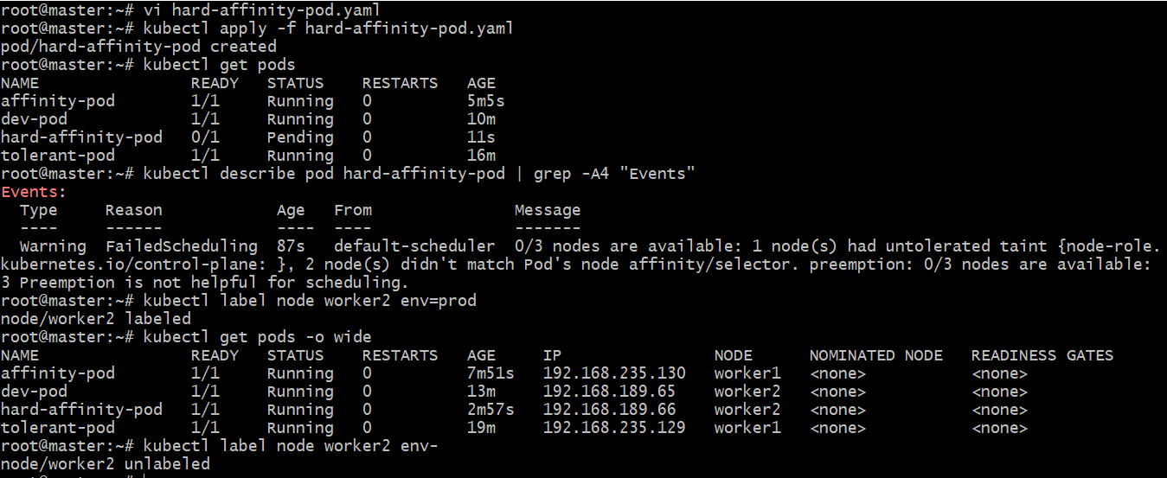
Task 6: Taint a Node and Use NoExecute with Toleration Seconds Taint a node with special=true:NoExecute. Create a pod with a tolerationSeconds field (e.g., 60 seconds) and observe it gets evicted after 60 seconds on the tainted node.

🪣 Step 1: Taint the Node
Let’s taint worker1:
kubectl taint nodes worker1 special=true:NoExecute
✅ Verify the taint:
kubectl describe node worker1 | grep Taints
You should see:
Taints: special=true:NoExecute

🧩 Step 2: Create a Pod with Toleration and tolerationSeconds
Create a YAML file named noexecute-pod.yaml:
apiVersion: v1
kind: Pod
metadata:
name: noexecute-pod
spec:
tolerations:
- key: "special"
operator: "Equal"
value: "true"
effect: "NoExecute"
tolerationSeconds: 60
containers:
- name: nginx
image: nginx

🧠 Explanation:
- The Pod can stay on the tainted node for 60 seconds, even though it doesn’t fully tolerate the taint.
- After 60 seconds, the kubelet will evict it automatically.

🚀 Step 3: Apply the Pod
kubectl apply -f noexecute-pod.yaml

🔍 Step 4: Verify Scheduling
Check that it’s running on the tainted node:
kubectl get pods -o wide
You should see:
NAME READY STATUS NODE
noexecute-pod 1/1 Running worker1

⏱️ Step 5: Wait and Observe Eviction
Wait ~60 seconds, then check again:
kubectl get pods
You’ll likely see:
NAME READY STATUS REASON NODE
noexecute-pod 0/1 Evicted worker1
Or the pod might disappear (if Kubernetes garbage-collects it quickly).
You can confirm via events:
kubectl describe pod noexecute-pod | grep -A4 "Events"
You should see a message similar to:
Pod was evicted due to node taint special=true:NoExecute

🧹 Step 6: Remove the Taint (Cleanup)
kubectl taint nodes worker1 special=true:NoExecute-

